THE GRUESOME THREESOME
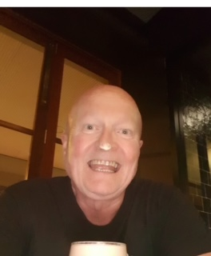
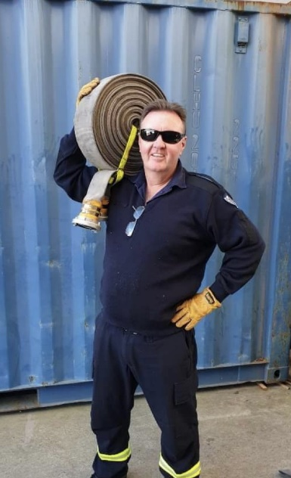
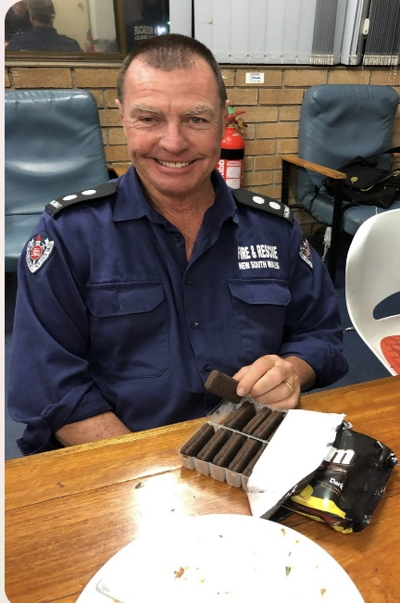

A joint farewell to send off
6452 Brett ‘Hooch’ Lennon
6487 Andy ‘H’ Haavisto
6761 Paul ‘Cullo’ Cullen
Friday 31st May 2pm
Club Cronulla, 41 Croydon St, Cronulla.
A short walk from Cronulla train station
$45 a head Payable to
13 B Platoon Syndo
BSB: 802 825 Acc: 100 921 804
Reference: Your name
includes a gift, food and the rest on the bar
Enquiries: David Nicholson 0413 701 598. david.nicholson@fire.nsw.gov.au
Dave Scott 0438 490 338. david.scott@fire.nsw.gov.au

